**Project 1: Display Message through Message Box**

1. Login To your Control Room.

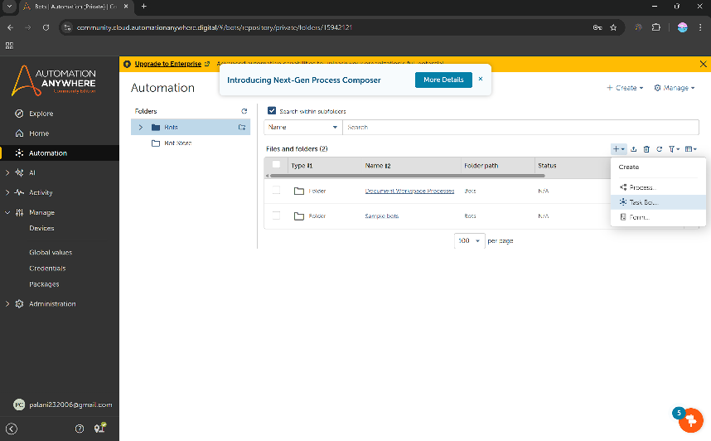

1. Click Automation in the Left Rail and click Create New Task Bot as Shown Above.

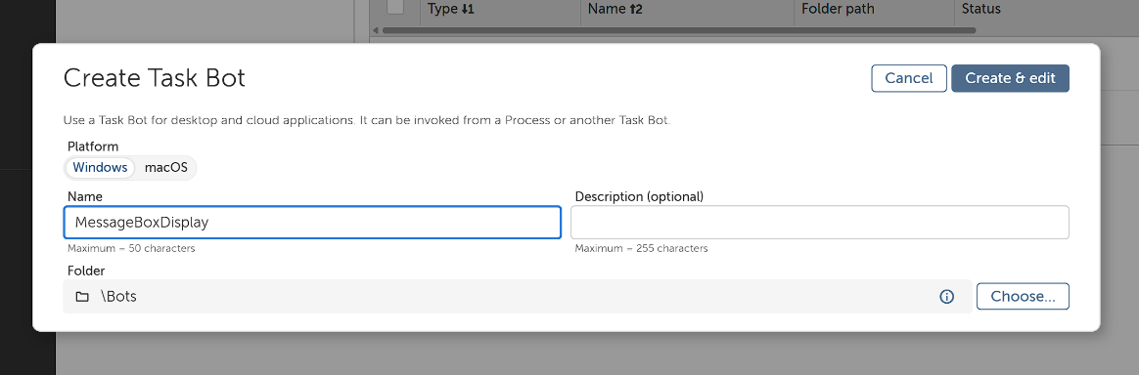

1. Enter the Bot Name and leave other options to default.
2. Now you will be re-directed to the Bot Action Panel.

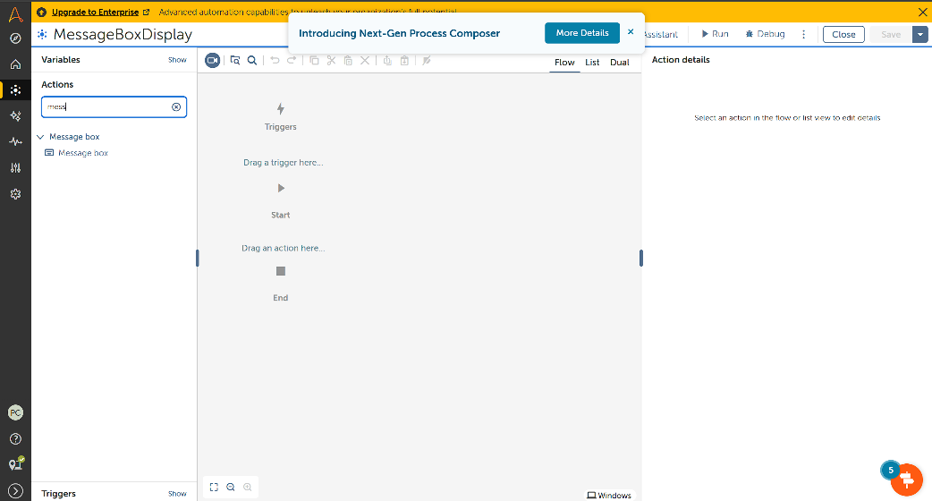

1. Search Message Box in Actions Package available in the Left Rail. Add it to the Action Panel

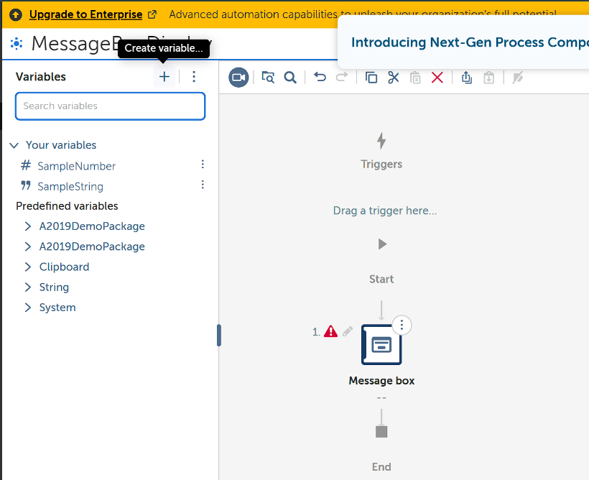

1. Let us learn to Create a Variable (in our case we will create a string variable). in Left Rail, select variable package and Create a New String Variable. I have named it has ‘description’. With Default Value: ’This is a Project to Demonstrate The Perfect Connection b/w Control Room and Bot Agent’

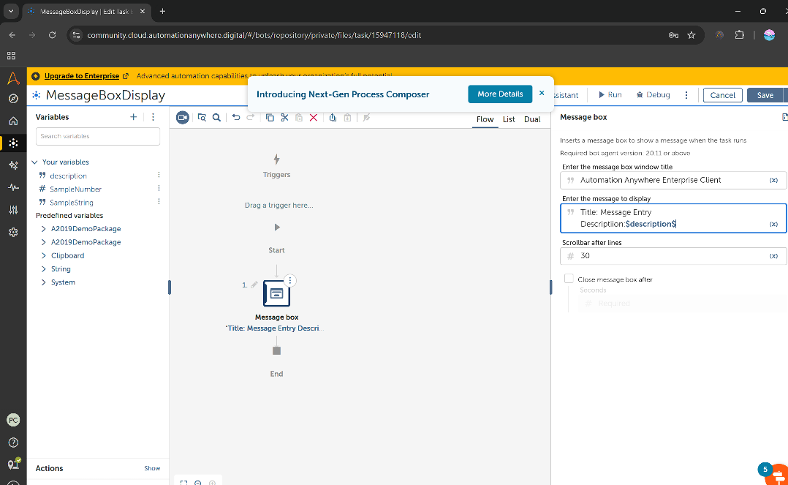

7.Click the message box in the action panel, it will open a dashboard on right side. Add title and message to be displayed.

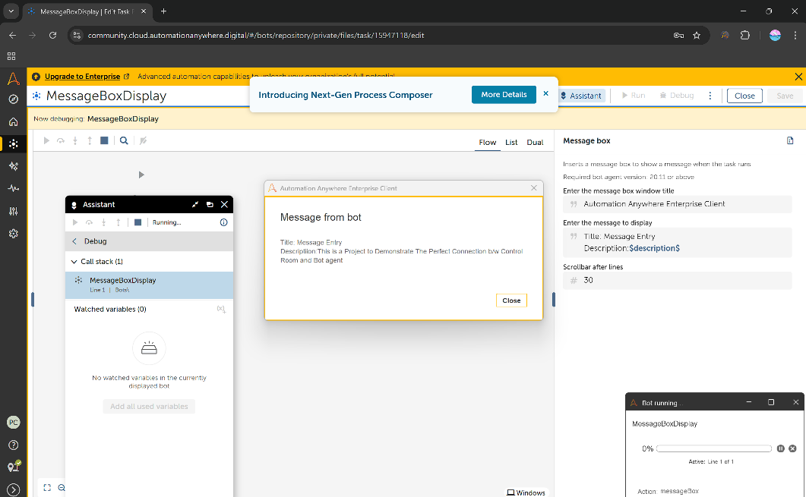

8.Finally Click Run, and Check the Output Being Displayed as a Message Box.

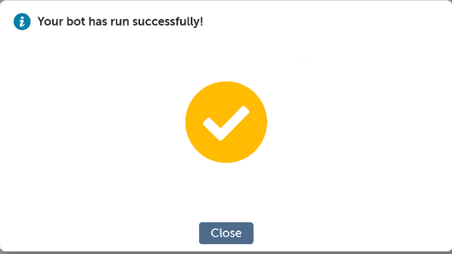

Bot has Run Successfully